Solution Architecture
Date | 18th June 2026
Team ID
Project Name | ShopEZ Stocks - MERN Stock Trading Simulator
Developed by | Gunturu Sai Teja
Role | Lead Developer and Systems Architect

What is a Solution Architecture?
Solution Architecture is a structural design that defines how all components of a software system interact to meet both functional and non-functional requirements. It describes the technology layers, data flows, external interfaces, and deployment infrastructure that power the application.

Four Core Architecture Goals
- Find the Best Technology Solution: We evaluated multiple stacks and selected MERN (MongoDB, Express, React, Node.js) for its JavaScript-unified codebase, massive community support, and natural alignment with high-frequency JSON-based data exchange.
- Describe Structure and Behavior to Stakeholders: Our architecture is divided into three clear tiers - Presentation (React frontend on Vite/local host), Application (Node/Express API backend), and Data Layer (MongoDB Atlas with In-Memory fallback).
- Define Features and Requirements: The architecture enforces strict role-based access control - the React router guards protected pages on the frontend, while Express middleware validates JWT Bearer tokens on protected API endpoints on the backend.
- Provide Delivery Specifications: The frontend is delivered as a static Vite build served locally or from a CDN. The backend runs as a continuous Node service executing Express routers and hosting a background market simulator. Environment variables manage all sensitive credentials.

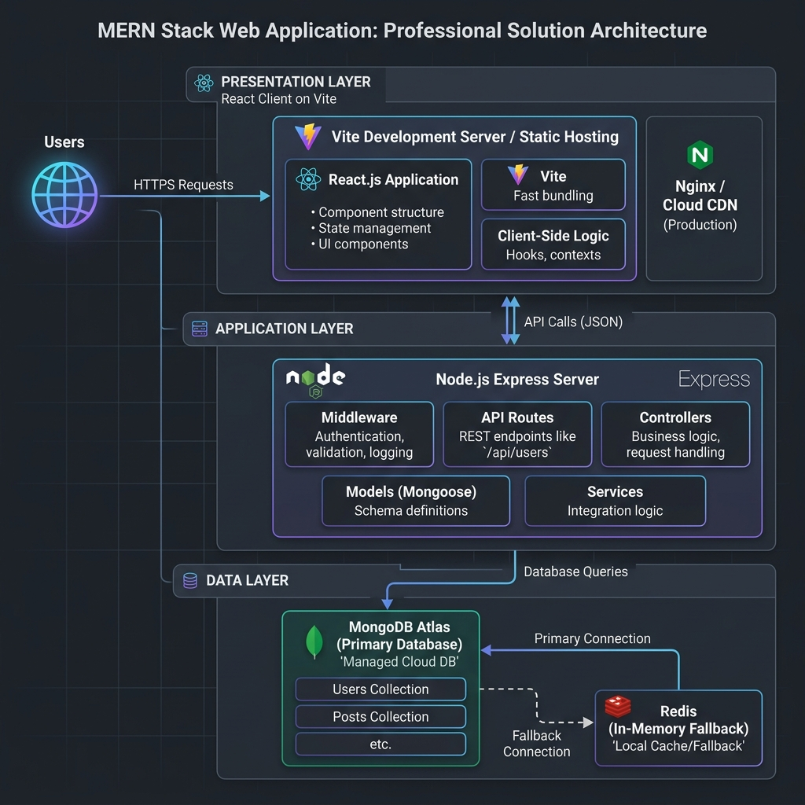

Architecture Component Breakdown
Layer | Technology | Responsibility
Presentation Layer | React.js (Vite) | Renders the UI, manages component state, handles routing via React Router, and renders graphs using Chart.js.
State Management | React Context API | Provides global authentication status and trader cash balance tracking across all pages.
HTTP Communication | Axios | Sends asynchronous API requests from frontend to backend with credentials using JWT Bearer headers.
Application Layer | Node.js + Express.js | Exposes RESTful API endpoints, validates requests, applies trading logic, and drives the background stock simulator.
Authentication | JWT + bcryptjs | Signs tokens, hashes passwords, and validates sessions via Bearer token request headers.
Database ORM | Mongoose | Enforces schema validation and provides query abstraction over MongoDB.
Database | MongoDB Atlas / memStore | Stores users, stock quotes, holdings, and transaction logs. Falls back to an in-memory store if MongoDB is down.
Hosting (Frontend) | Vite / Vercel | Serves the compiled React static files globally or locally with zero configuration.
Hosting (Backend) | Express / Vercel | Executes Express API and starts the stock simulation engine loop (updates every 6 seconds).

